Breaking down the Rocknel Passthough 856 EDI TRANSACTION

The 856 is an Advanced Shipment Notification (ASN). As the name states it is sent in before a shipment in order to notify Rocknel of what is being physically sent and how it’s being sent.

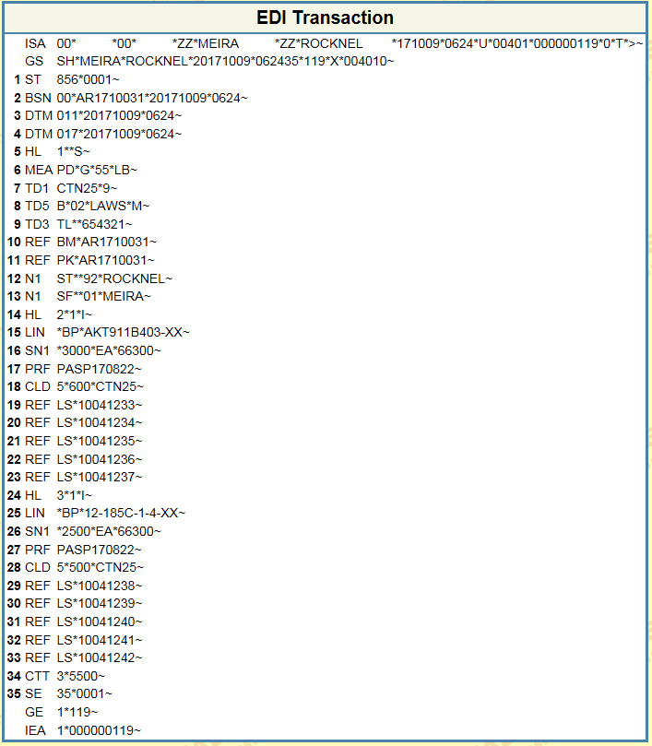

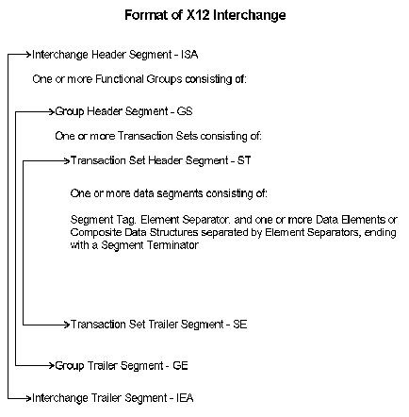

At first and maybe second glance it looks like gibberish but once you understand the key points it’s pretty easy to see what’s going on. For the moment let’s examine the .csv file that was used to generate this 856 document.

|  |  |  |  |  |  |  |  |
| --- | --- | --- | --- | --- | --- | --- | --- |
| SERIAL | INVOICE_NO | PALETTE_NO | CUST_ODR_NO | ITEM_NO | CONTROL_NO | QTY_PER_BOX | CASE_QTY |
| 10041233 | AR1710031 | K-00981 | PASP170822 | AKT911B403-XX | 5239150001 | 600 | 5 |
| 10041234 | AR1710031 | K-00981 | PASP170822 | AKT911B403-XX | 5239150002 | 600 | 5 |
| 10041235 | AR1710031 | K-00981 | PASP170822 | AKT911B403-XX | 5239150003 | 600 | 5 |
| 10041236 | AR1710031 | K-00981 | PASP170822 | AKT911B403-XX | 5239150004 | 600 | 5 |
| 10041237 | AR1710031 | K-00981 | PASP170822 | AKT911B403-XX | 5239150005 | 600 | 5 |
| 10041238 | AR1710031 | K-00981 | PASP170822 | 12-185C-1-4-XX | 5238976001 | 500 | 5 |
| 10041239 | AR1710031 | K-00981 | PASP170822 | 12-185C-1-4-XX | 5238976002 | 500 | 5 |
| 10041240 | AR1710031 | K-00981 | PASP170822 | 12-185C-1-4-XX | 5238976003 | 500 | 5 |
| 10041241 | AR1710031 | K-00981 | PASP170822 | 12-185C-1-4-XX | 5238976004 | 500 | 5 |
| 10041242 | AR1710031 | K-00981 | PASP170822 | 12-185C-1-4-XX | 5238976005 | 500 | 5 |

Effectively 5 boxes of AKT911B403-XX at 600 Pieces per box and 5 boxes of 12-185C-1-4-XX at 500 pieces per box are being sent to Rocknel on Purchase Order “PASP170822”.

This is noted on the item level Segments of the 856 HL2 and HL3.

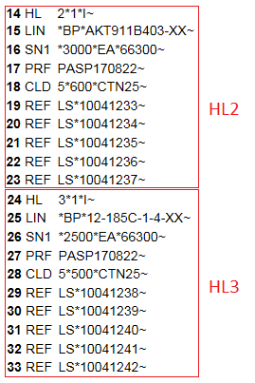

To fully understand the two Hierarchical Levels below is a breakdown of the segment fields.

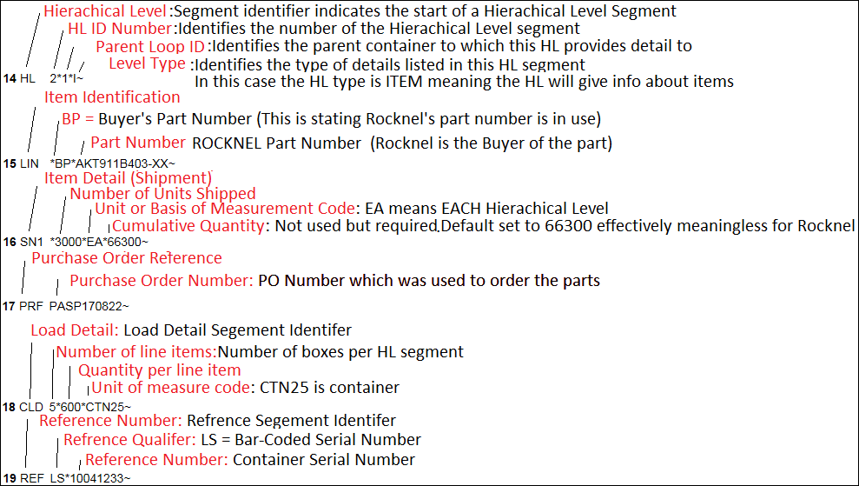

It’s key to note however that Unlike HL2 and HL3 HL1 does not contain parts and part numbers as the level type of HL1 is SHIPMENT rather than ITEM which contains information about the shipment as a whole rather than the item. HL1 is the parent field of the item level HL segments in this example.

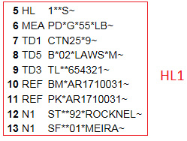

The format of HL1 is a little different. A detailed view of this can be seen below.

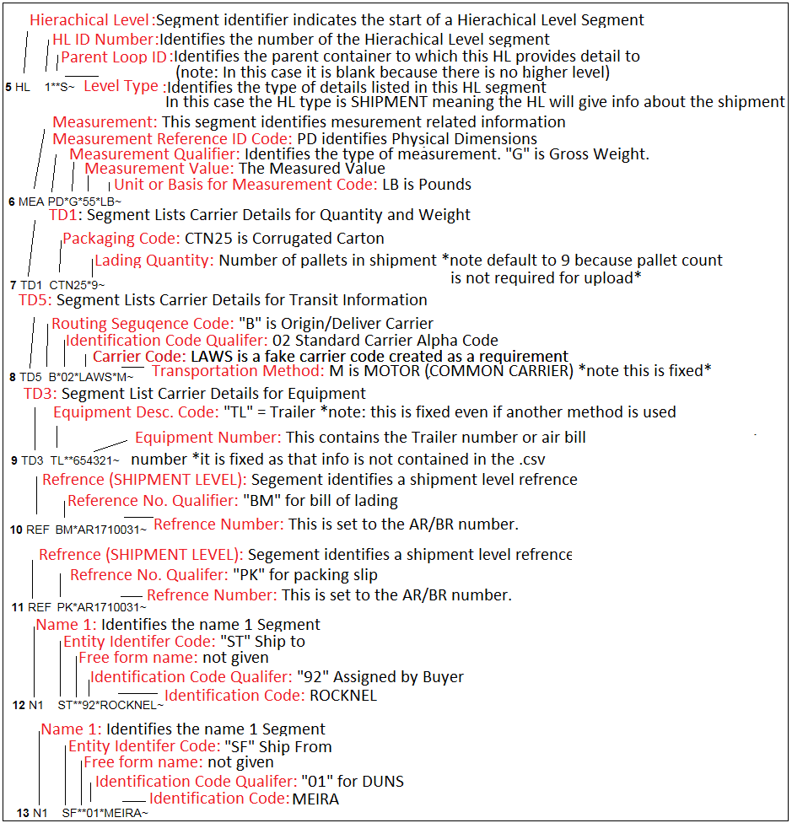

For a quick summary of what was detailed so far:

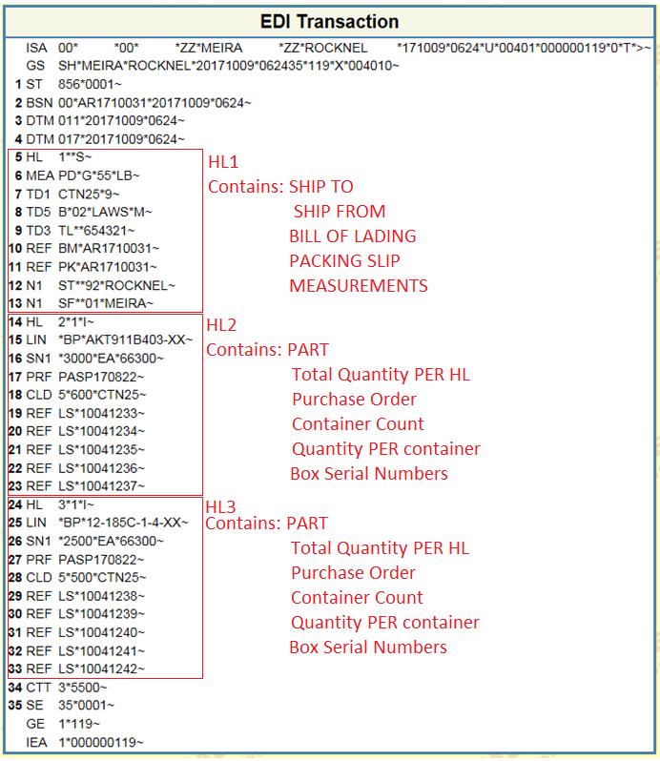

The last two pieces of the puzzle are the header and the footer:

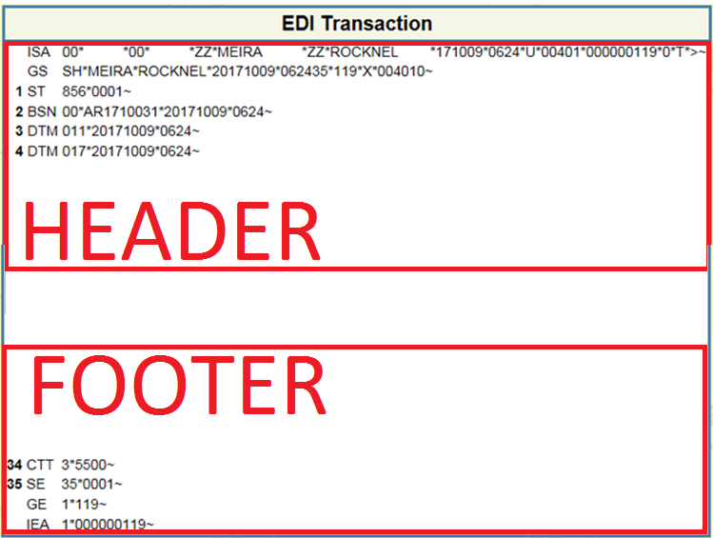

The header and footer basically delineate the start end and type of order. See below for a detailed breakdown.

This segment is the header.

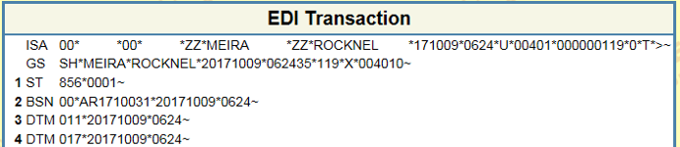

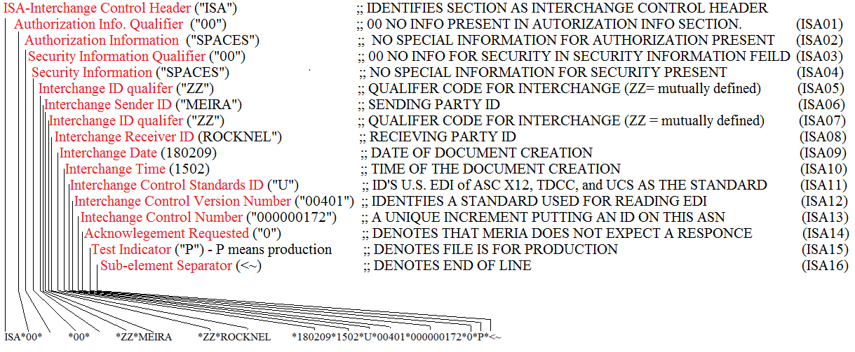

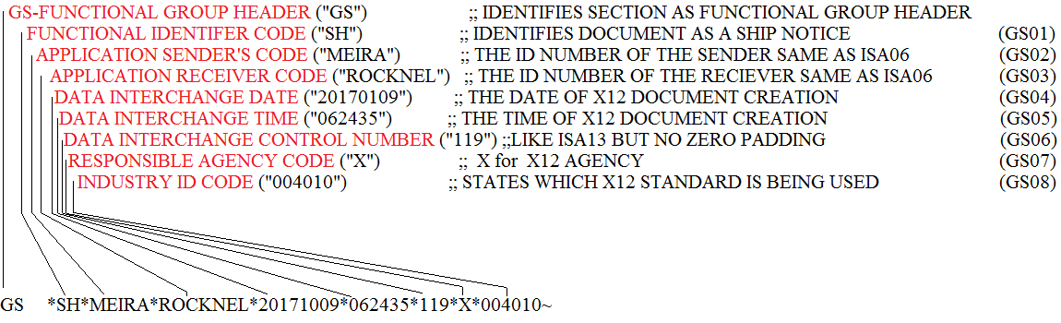

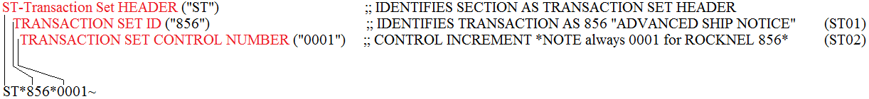

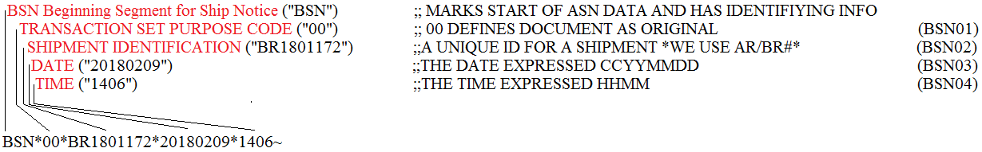

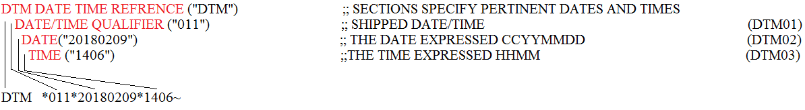

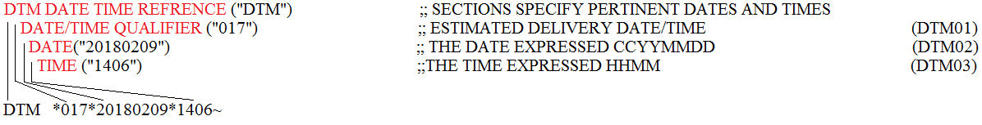

*note: the header has 2 date time fields and both are the same except for the qualifier. Technically these should not match but because it does not matter and we do not require accurate ship/delivery dates this is set to match.*

This segment is the footer:

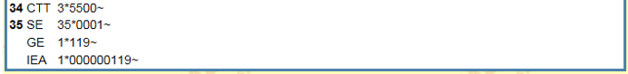

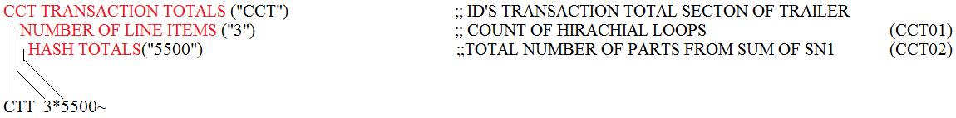

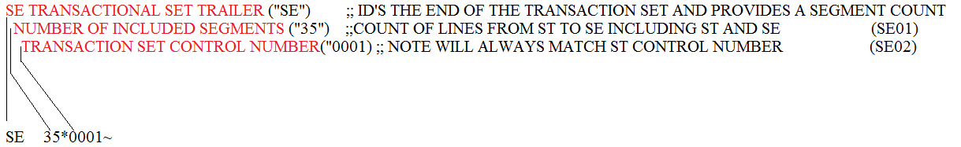

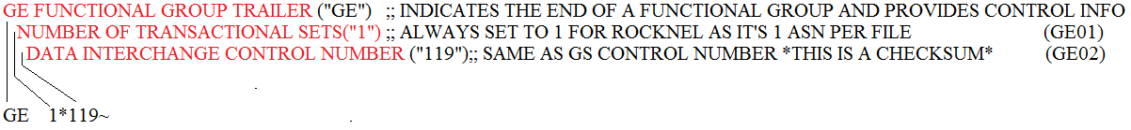



NOW THAT EVERY SEGMENT HAS BEEN EXPLAINED IT’S TIME FOR VARIABLE ASSIGNEMENT AND CREATION FOR USE IN GENERATING ASN OUTPUT FROM THE INPUT. FIRST LETS LOOK AT FIXED VALUES. THESE ARE THINGS THAT DO NOT CHANGE BETWEEN SUPPLIER ASNS FOR ROCKNEL.